EXPT
NO:4A EXPLORATORY DATA ANALYSIS (EDA) – DATA
INSPECTION, FILTERING, STATISTICAL ANALYSIS
AND CORRELATION
Aim:
To perform data inspection, filtering, grouping, aggregation, descriptive statistical analysis, and correlation analysis on the Driver Standings dataset using Pandas and visualize the results using Matplotlib.
Algorithm:
1. Import the required Pandas, NumPy and Matplotlib libraries.
2. Read the driver_standings(1).csv file using Pandas.
3. Display the dataset and inspect the first few records.
4. Find the number of rows and columns and display the data types.
5. Generate the statistical summary of the dataset.
6. Filter driver standings based on points and finishing-position conditions.
7. Sort driver standings based on points and wins.
8. Group the data based on driver ID and calculate maximum points and wins.
9. Calculate mean, median, minimum, maximum and standard deviation of points.
10. Calculate the correlation between points and wins.
11. Create bar chart, line chart, scatter plot, histogram and box plot using Matplotlib.
12. Display the results and interpret the obtained data.

Program:
import pandas as pd
import numpy as np
import matplotlib.pyplot as plt
# Read dataset
df = pd.read_csv("driver_standings(1).csv")
# Display dataset
print(df)
# Display first five records
print(df.head())
# Display shape
print(df.shape)
# Display data types
print(df.dtypes)

# Display statistical summary
print(df.describe())
# Filter standings with points greater than 100
print(df[df["points"] > 100])
# Filter first-position standings
print(df[df["position"] == 1])
# Sort standings by points
print(df.sort_values("points", ascending=False))
# Sort standings by wins
print(df.sort_values("wins", ascending=False))
# Driver-wise maximum points
print(df.groupby("driverId")["points"].max())

# Driver-wise maximum wins
print(df.groupby("driverId")["wins"].max())
# Calculate mean
print("Mean Points:", df["points"].mean())
# Calculate median
print("Median Points:", df["points"].median())
# Calculate minimum
print("Minimum Points:", df["points"].min())
# Calculate maximum
print("Maximum Points:", df["points"].max())
# Calculate standard deviation
print("Standard Deviation:", df["points"].std())
# Display correlation matrix
print(df[["points", "wins"]].corr())

# Display correlation between points and wins
print("Correlation:", df["points"].corr(df["wins"]))
# Bar chart
top10 = df.groupby("driverId")["points"].max().sort_values(ascending=False).head(10)
plt.bar(top10.index.astype(str), top10.values)
plt.title("Top 10 Driver IDs by Maximum Points")
plt.xlabel("Driver ID")
plt.ylabel("Maximum Points")
plt.show()
# Line chart
first20 = df.head(20)
plt.plot(range(1, len(first20)+1), first20['points'], marker='o')
plt.title("Points of First 20 Driver Standings Records")
plt.xlabel("Record")
plt.ylabel("Points")
plt.show()

# Scatter plot
plt.scatter(df["points"], df["wins"])
plt.title("Points vs Wins")
plt.xlabel("Points")
plt.ylabel("Wins")
plt.show()
# Histogram
plt.hist(df["points"], bins=20)
plt.title("Points Distribution")
plt.xlabel("Points")
plt.ylabel("Number of Standings Records")
plt.show()
# Box plot
plt.boxplot(df["points"])
plt.title("Points Box Plot")
plt.ylabel("Points")
plt.show()

# Position distribution
position_counts = df["position"].value_counts().sort_index()
print(position_counts.head(15))
plt.bar(position_counts.head(15).index.astype(str), position_counts.head(15).values)
plt.title("Finishing Position Distribution")
plt.xlabel("Position")
plt.ylabel("Number of Records")
plt.show()

# Missing values
print("Missing Values:")
print(df.isnull().sum())
# Duplicate rows
print("Duplicate Rows:", df.duplicated().sum())
# Numerical correlation matrix
print(df.corr(numeric_only=True))

Output:
driverStandingsId | raceId | driverId | points | position | positionText | wins
1 | 18 | 1 | 10.0 | 1 | 1 | 1
2 | 18 | 2 | 8.0 | 2 | 2 | 0
3 | 18 | 3 | 6.0 | 3 | 3 | 0
4 | 18 | 4 | 5.0 | 4 | 4 | 0
5 | 18 | 5 | 4.0 | 5 | 5 | 0
6 | 18 | 6 | 3.0 | 6 | 6 | 0

driverStandingsId | raceId | driverId | points | position | positionText | wins
73265 | 1144 | 822 | 0.0 | 22 | 22 | 0
73266 | 1144 | 858 | 0.0 | 23 | 23 | 0
73267 | 1144 | 860 | 7.0 | 18 | 18 | 0
73268 | 1144 | 861 | 5.0 | 19 | 19 | 0
73269 | 1144 | 859 | 4.0 | 21 | 21 | 0
73270 | 1144 | 862 | 0.0 | 24 | 24 | 0

Statistical Summary:
driverStandingsId raceId driverId points position wins
count 34863.000000 34863.000000 34863.000000 34863.000000 34863.000000 34863.000000
mean 43176.154232 584.413562 316.932909 14.704423 19.716720 0.277343
std 21934.276898 292.275820 274.665660 38.978094 16.293401 1.032618
min 1.000000 1.000000 1.000000 0.000000 1.000000 0.000000
25% 19834.500000 354.000000 88.000000 0.000000 8.000000 0.000000
50% 50044.000000 603.000000 223.000000 1.000000 16.000000 0.000000
75% 62054.500000 805.000000 521.000000 10.000000 26.000000 0.000000
max 73270.000000 1144.000000 862.000000 575.000000 108.000000 19.000000

Filtered and grouped output:
Driver standings with points > 100:
driverId points position wins
4 103.0 2 4
8 110.0 1 6
4 109.0 3 4
4 108.0 1 6
30 106.0 2 6
4 108.0 1 6
30 116.0 1 7
4 116.0 2 6
30 116.0 2 7
4 126.0 1 7
30 121.0 2 7
4 134.0 1 7
First-position standings:
driverId points position wins
1 10.0 1 1
1 14.0 1 1
8 19.0 1 1
8 29.0 1 2
8 35.0 1 2
1 38.0 1 2
9 42.0 1 1
13 48.0 1 3
1 48.0 1 3
1 58.0 1 4
1 62.0 1 4
1 70.0 1 4

Output:
Top 10 Driver IDs by Maximum Points
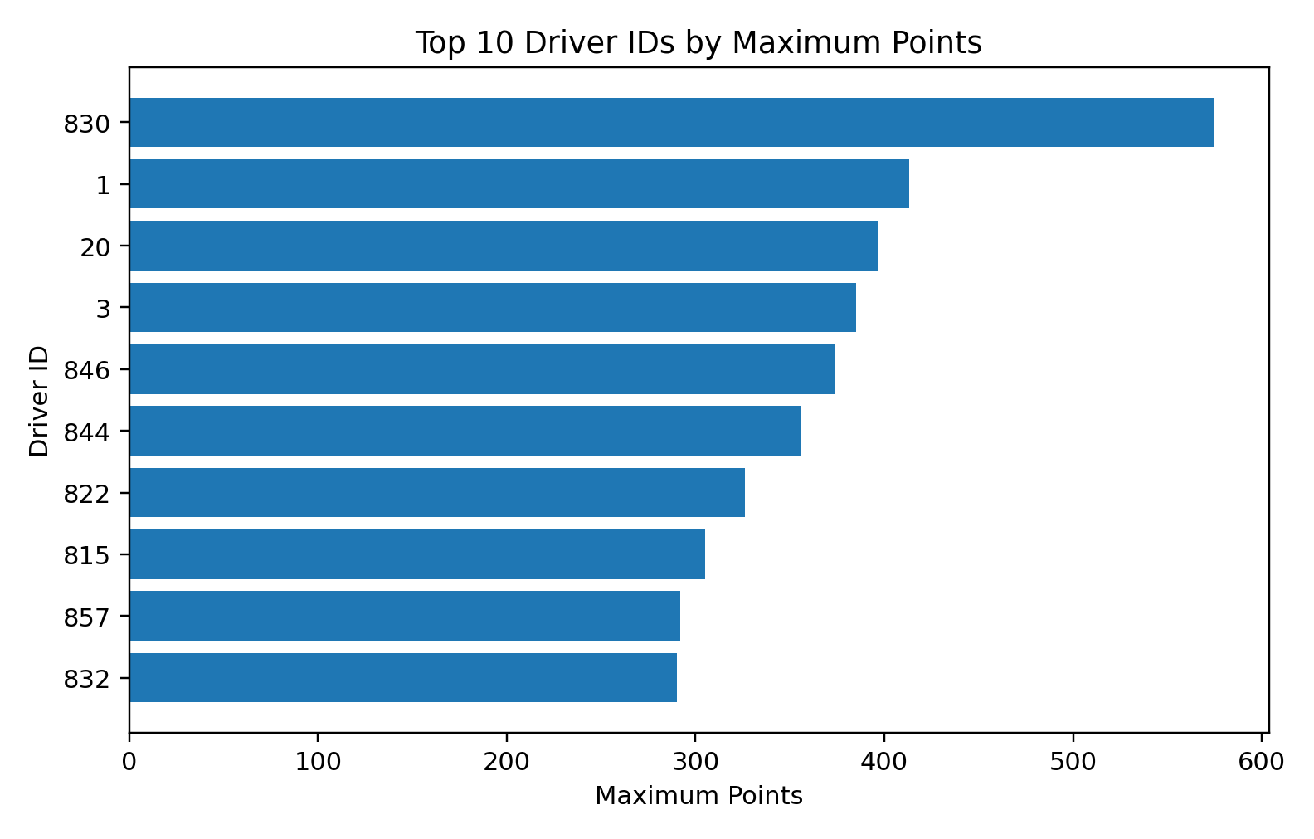
Points Distribution
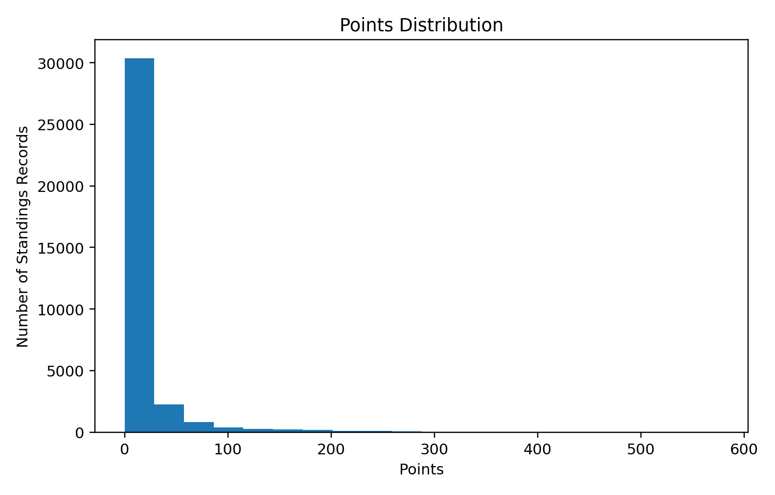

Output:
Points vs Wins
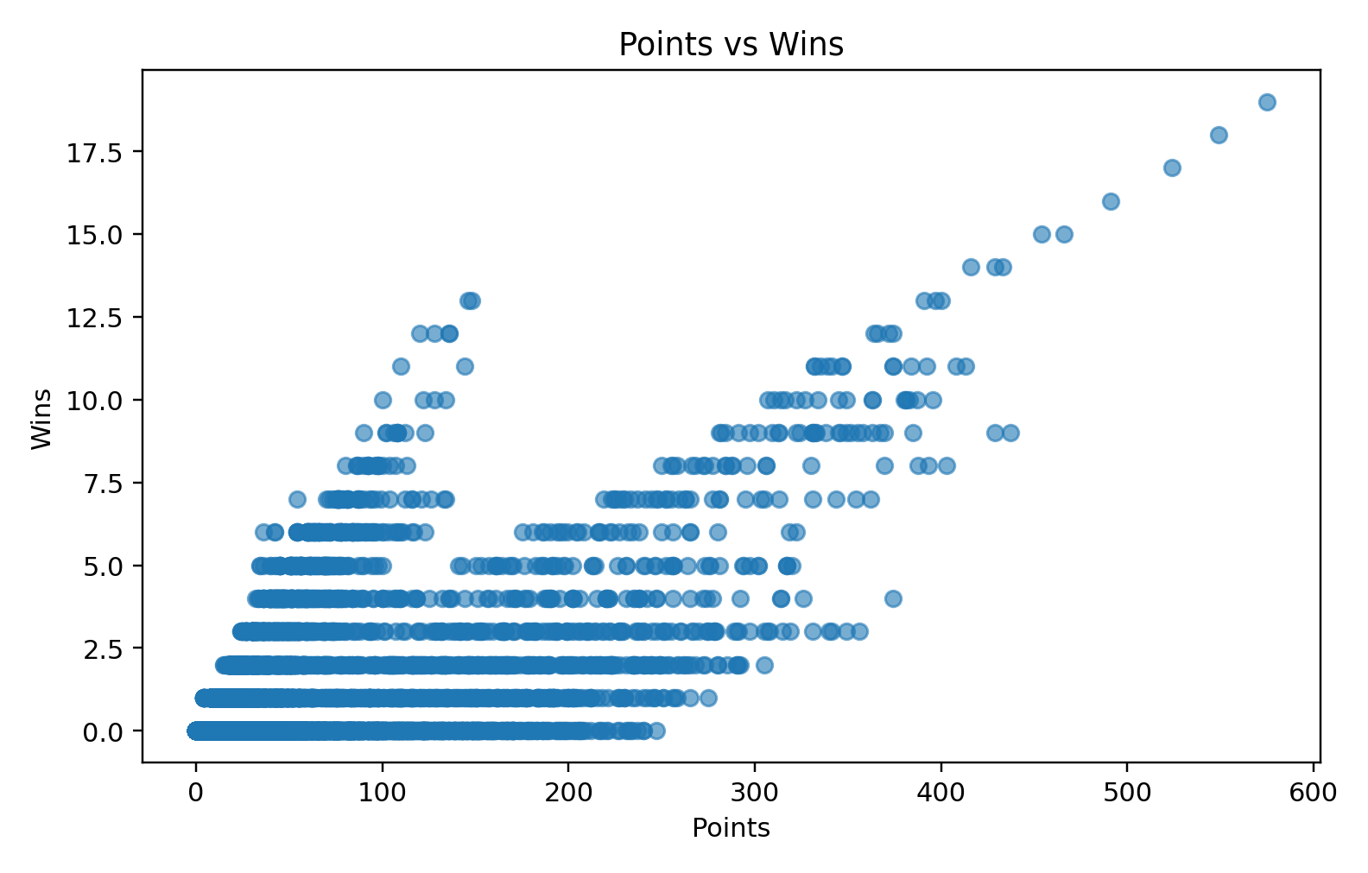
Finishing Position Distribution
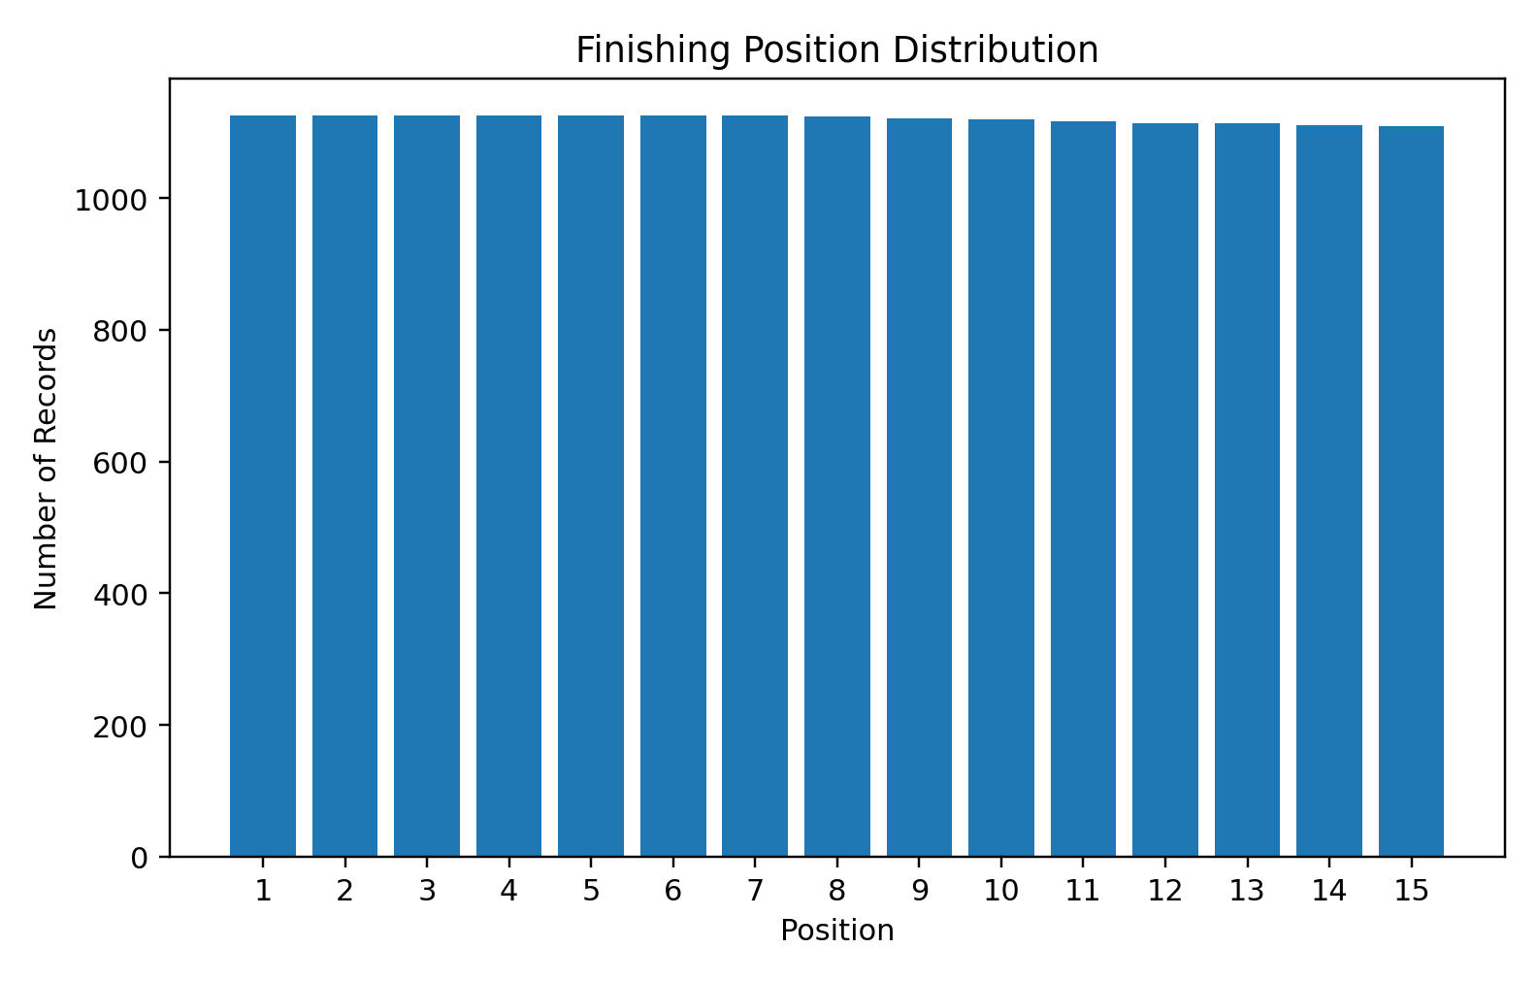

EXPT
NO:4B EXPLORATORY DATA ANALYSIS-DATA INSPECTION,
FILTERING, STATISTICAL ANALYSIS AND
CORRELATION
AIM:
To visualize and analyze the Driver Standings dataset using Python and create different charts to understand driver points, wins, finishing positions, and identify important patterns.
PROCEDURE:
1. Start the program.
2. Import Pandas, Matplotlib, and NumPy libraries.
3. Load the Driver Standings CSV dataset.
4. Display the first few records using head().
5. Identify the numerical columns using select_dtypes().
6. Create a bar chart to compare driver IDs based on maximum points.
7. Create a box plot to examine the distribution and outliers in driver points.
8. Create a line chart to analyze points of the first 20 standings records.
9. Add suitable titles and axis labels.
10. Display all the visualizations.
11. Analyze the graphs and identify important patterns.
12. Stop the program.

CODE:
import pandas as pd
import matplotlib.pyplot as plt
import numpy as np
# Load Driver Standings dataset
df = pd.read_csv("driver_standings(1).csv")
# Display dataset
print("Dataset Preview:")
display(df.head())
# Select numerical columns
num_cols = df.select_dtypes(include="number").columns
print("\nNumerical columns:")
print(num_cols.tolist())
# BAR CHART
top10 = df.groupby("driverId")["points"].max().sort_values(ascending=False).head(10)
plt.figure(figsize=(10,5))
plt.bar(top10.index.astype(str), top10.values)
plt.title("Top 10 Driver IDs by Maximum Points")
plt.xlabel("Driver ID")
plt.ylabel("Maximum Points")
plt.xticks(rotation=45)
plt.tight_layout()
plt.show()

# BOX PLOT
plt.figure(figsize=(8,5))
plt.boxplot(df["points"].dropna(), vert=False)
plt.title("Box Plot of Driver Points")
plt.xlabel("Points")
plt.tight_layout()
plt.show()
# LINE CHART
first20 = df.head(20)
plt.figure(figsize=(10,5))
plt.plot(range(1, len(first20)+1), first20['points'], marker='o')
plt.title("Points of First 20 Driver Standings Records")
plt.xlabel("Record")
plt.ylabel("Points")
plt.grid()
plt.tight_layout()
plt.show()

OUTPUT:
Top 10 Driver IDs by Maximum Points
Box Plot of Driver Points
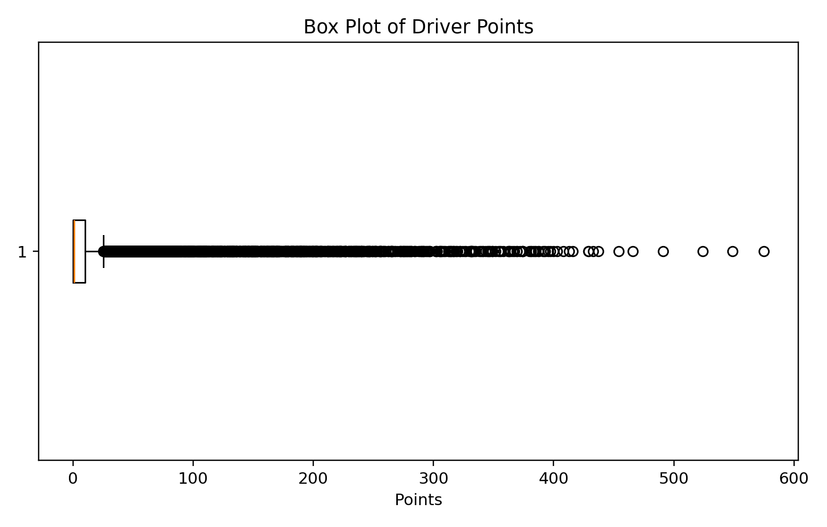

Output:
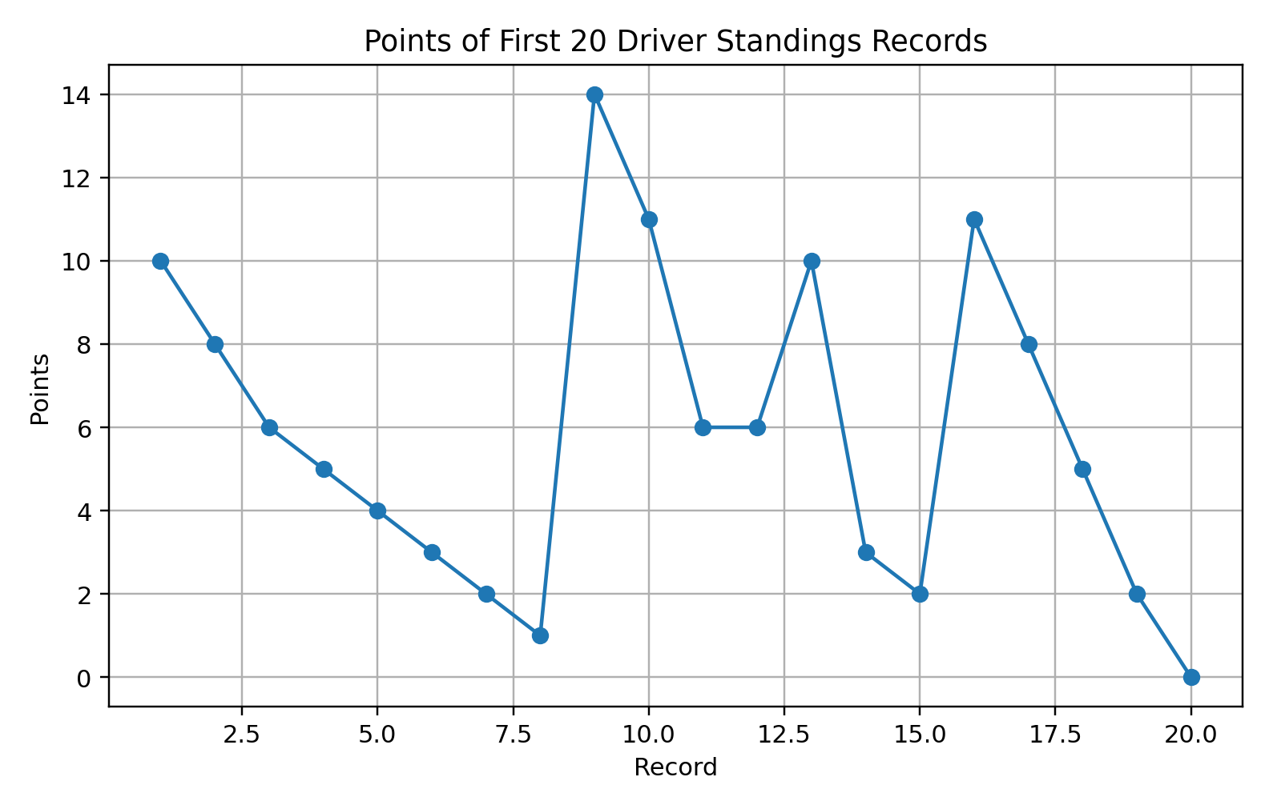
Result:
The Driver Standings dataset was successfully inspected, filtered, grouped, statistically analyzed, and visualized. The generated charts show patterns in driver points, wins, and finishing positions, while the correlation analysis provides a numerical measure of the relationship between points and wins.

